CHARTERING REPORT

COVER
Group Number: C1.034
Repository: https://github.com/CarlosCerdaMorales/dp2-c1-034
Workgroup Members:
- Sergio Cantillo Blanco – sercanbla@alum.us.es
- Carlos Cerdá Morales – carcermor@alum.us.es
- Loubna Founoun ElAoud – loufouela@alum.us.es
- José Luis Moraza Vergara – josmorver@alum.us.es
- Claudia Oviedo Govantes – claovigov@alum.us.es

Date: 17/02/2025

TABLE OF CONTENTS
CHARTERING REPORT 1
COVER 1
TABLE OF CONTENTS 1
EXECUTIVE SUMMARY 1
REVISION TABLE 1
INTRODUCTION 2
CONTENTS 2
Recruitment Process 2
Members 2
Commitment Statement 5
Performance Indicators 7
Rewards For Good Performance 7
Rewards For Bad Performance 7
Conditions To Be Fired 7
CONCLUSIONS 8
BIBLIOGRAPHY 8

EXECUTIVE SUMMARY
This report details the formation and commitments of Workgroup C1.034 on the subject “Diseño y Pruebas II” imparted at the University of Seville. The team, formed via the university’s discussion board, has pledged to collaborate effectively and adhere to the syllabus and grading criteria. Performance Indicators ensure accountability by measuring task completion, engagement, and overall contributions. This document sets the foundation for a structured and productive workflow.

REVISION TABLE
Revision Number | Date | Description
1.0 | 16/02/2025 | We started the report template and structure.
1.1 | 17/02/2025 | We complete the report contents after a group meeting.
2.0 | 18/02/2025 | After completing the contents, we write the summaries and conclusions of the document.
2.1 | 18/02/2025 | We revise styling and formats.

INTRODUCTION
This report presents the formation, commitments, and performance indicators of the Workgroup C1.034 for the following subject “Diseño y Pruebas II”. It provides a detailed overview of the process by which the team was established, including the recruitment procedure and the collaborative efforts that ensure a productive and successful teamwork dynamic. The purpose of this report is not only to present the structure of the team but also to define clear expectations for participation, task completion, and overall performance evaluation. Through this approach, the group aims to achieve both individual success and collective achievement in alignment with the course objectives.

CONTENTS

Recruitment Process
The recruitment process was made using the discussion board provided by the University of Seville. Inside the recruiting section, our manager published a proposal looking for diligent members. Once the proposal was created, each member had to show their interest by sending a request to be part of the workgroup. The request had to be accepted by the manager to be part of the team.
The link of the thread: https://ev.us.es/webapps/discussionboard/do/message?action=list_messages&course_id=_89154_1&nav=discussion_board&conf_id=_426211_1&forum_id=_253523_1&message_id=_455725_1

Members
Name: Sergio
Surnames: Cantillo Blanco
Address: Calle Hermano Bernardo Sulpicio, N6 11407 Jerez De la Frontera, Cádiz
Corporate Email: sercanbla@alum.us.es
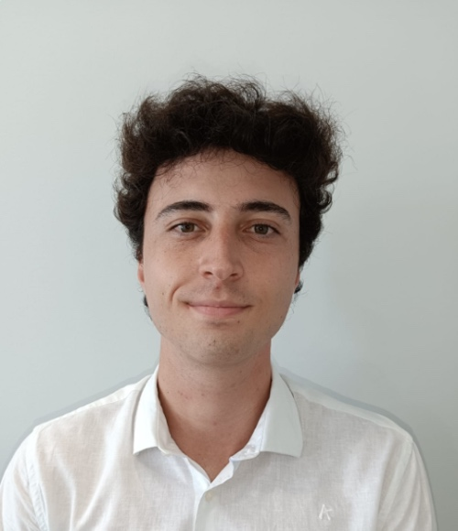

Name: Carlos
Surnames: Cerdá Morales
Address: Calle Bami, N6, 41013 Sevilla
Corporate Email: carcermor@alum.us.es
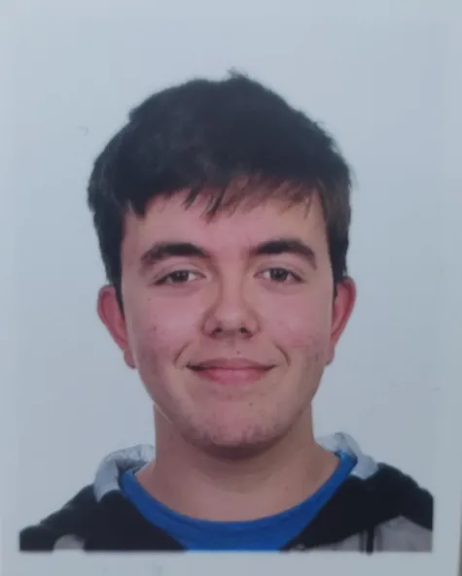

Name: Loubna
Surnames: Founoun ElAoud
Address: Calle San Salvador, N60, 41701 Dos Hermanas, Sevilla
Corporate Email: loufouela@alum.us.es


Name: José Luis
Surnames: Moraza Vergara
Address: Calle Manuel Cansino Vélez, N36, 41950 Castilleja de la Cuesta, Sevilla
Corporate Email: josmorver@alum.us.es


Name: Claudia
Surnames: Oviedo Govantes
Address: Calle Marqués de Santillana, N1, 41702 Dos Hermanas, Sevilla
Corporate Email: claovigov@alum.us.es

Commitment Statement
We, the undersigned, hereby commit to working together in this subject with dedication, collaboration, and mutual support. We acknowledge that we have thoroughly reviewed and understood the syllabus, including its objectives, course content, and, most importantly, the evaluation and grading procedures.
The main objective of the project will be to successfully achieve a passing grade of a 5 out of 10 by making sure to meet the minimum requirements expected from the final product to obtain our desired grade.
With this understanding, we pledge to actively engage in all learning activities, complete assignments with integrity, and seek continuous improvement.
By signing below, we affirm our commitment to these principles and to supporting one another in successfully completing this course.
Sergio Cantillo Blanco – 17/02/2025
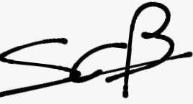
Carlos Cerdá Morales – 17/02/2025
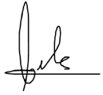

Loubna Founoun ElAoud – 17/02/2025
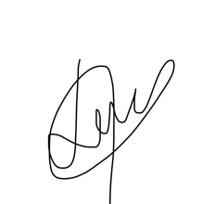
José Luis Moraza Vergara – 17/02/2025
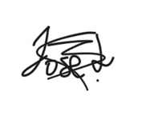
Claudia Oviedo Govantes – 17/02/2025

Performance Indicators
We will assess our performance using a performance indicator based on the following rule: The objective is to achieve a score of 5 by completing all mandatory deliverables. The expected performance indicator is calculated as the objective minus the current completeness of the mandatory requirements. If the current grade is below the expected indicator, performance will be considered poor. If the current grade exceeds the expected indicator, performance will be considered excellent, and we will update the objective report accordingly to align with the new performance level.

Rewards For Good Performance
The reward for good performance is the successful passing of the deliverable, which directly contributes to passing the subject. Additionally, meeting the requirements reinforces the ability to develop and work in a professional environment, fostering skills such as precision, accountability, and adherence to industry standards. By consistently delivering high-quality work, students gain valuable experience that prepares them for real-world challenges, ensuring both academic success and professional growth.

Rewards For Bad Performance
The reward for bad performance is the consequence of failing to meet the required standards. This includes not passing the deliverable, which can negatively impact progress in the subject and, ultimately, academic performance. Additionally, poor performance results in missed opportunities to develop essential professional skills, such as meeting deadlines, following specifications, and working within defined constraints. In a real-world setting, consistent failure to meet expectations can lead to lost credibility, limited career opportunities, and professional setbacks. Therefore, the only true outcome of bad performance is a setback in both academic and professional growth.

Conditions To Be Fired
We must be strict when it comes to the commitment of our members, therefore, anyone who does not abide by these rules, shall be fired:
- We shall attend every scheduled group meeting. Exceptions will be made to those who have a valid reason to skip, but they must make sure to read and comprehend the reports of the meetings missed.
- Anyone who disrespects another member of the group shall immediately be fired from the group.
- Those who do not finish their assigned task in time repeatedly will be kicked out of the group.
- Anyone who does not report their changes to the group consistently, shall be fired.
- Members that do not show up for the laboratory lessons repeatedly will be kicked out.
After thorough discussion, we decided that these are the minimum conditions that every member must abide by to continue working in the group. All members are aware that not following these conditions will result in their immediate expulsion from the team.

CONCLUSIONS
After thorough consideration, the group has reached an agreement on the goals of the project, as well as the rules and conditions that every individual must follow to have a successful result. Expectations to be met by every member have been set and anyone who does not will be punished, and in the opposite case, they will be rewarded.

BIBLIOGRAPHY
Intentionally Blank

